UW Foster School of Business
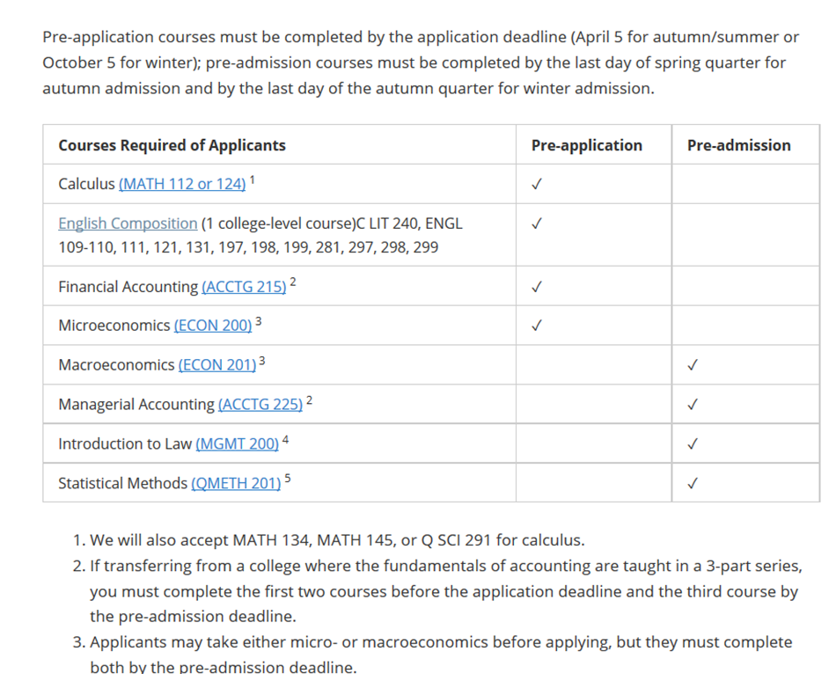

Each year, approximately 30-50% of applicants—between 550 and 650—are admitted. For all applicants, index scores are created from three admissions factors, which are standardized, then assigned the following weights.

Combined GPA (40%)
Pre-application GPA (25%)
Writing Skills Assessment (35%)

Beyond this index, consideration is given to such factors as cultural experiences, significantly higher recent grades, exceptional extracurricular activities or leadership experience and the effect of personal disadvantage on earlier education. We review all applicants together (current and returning UW, transfer, international transfer, and running start) and only use current standing for post-admission demographic data.

